5、Buzzer control

**Follow the steps to splice the building blocks：**

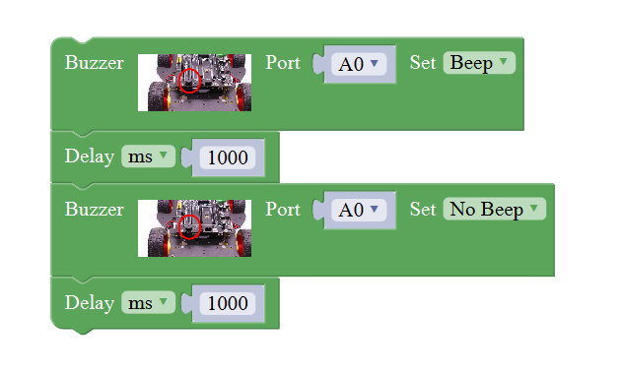

**1、Experimental building blocks ：**

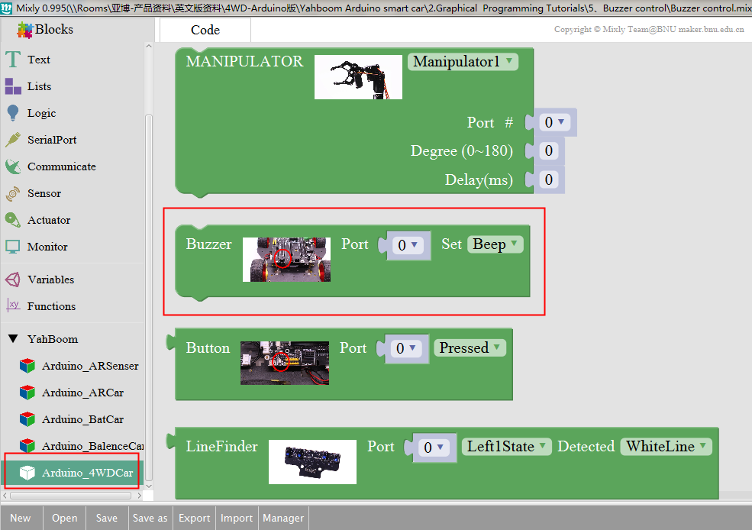

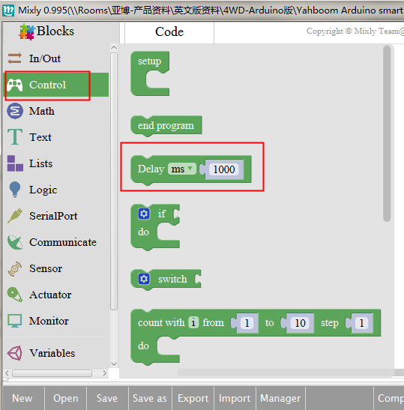

**2、Experimental verification：**

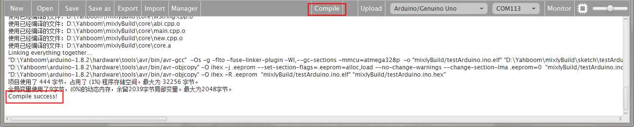

a、After splicing, select the compile button above the picture, wait for the completion of the compiler, the following box will prompt the compiler successfully, if prompt the compile failure is the problem of building block splicing.

b、After compiled , select **Arduino/Genuino Uno** follow the picture,

selects the serial number of the corresponding board.

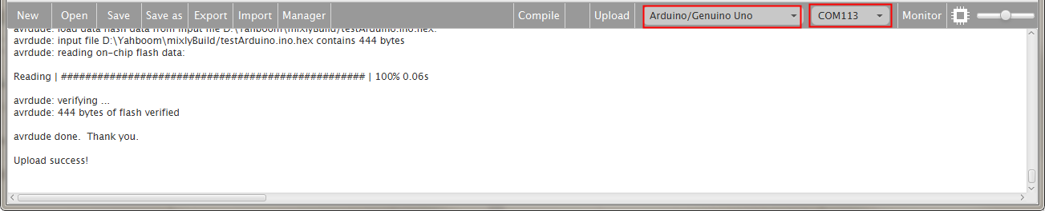

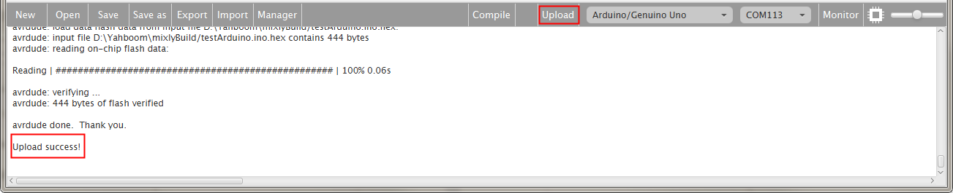

c、After configured,select the upload button above the picture, wait for the following box prompt the upload successfully. Observe whether the buzzer calls once in a second,we can change the time, and try the above steps to compile upload again, try the effect.